In FOCUS go to the Classified tab
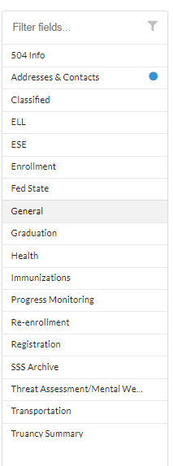
Look for the TIDE Access Code
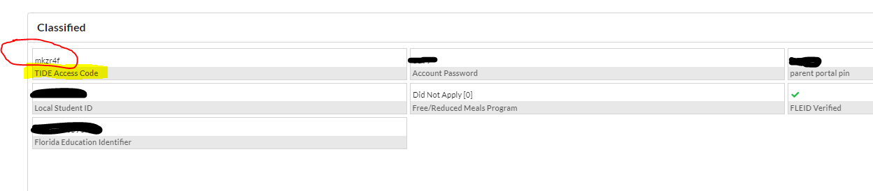Using this code proceed to the Family Portal https://fl-familyportal.cambiumast.com/#/
In addition to your ACCESS CODE, you will need your child’s date of birth and their name as it appears in FOCUS
Make sure you have the current year of 2022-2023.
